**Summary of Liner Model Data:**

summary(age_lm)

|  |
| --- |
| Call:  lm(formula = earn ~ age, data = heights_df)  Residuals:  Min 1Q Median 3Q Max  -25098 -12622 -3667 6883 177579  Coefficients:  Estimate Std. Error t value Pr(>|t|)  (Intercept) 19041.53 1571.26 12.119 < 2e-16 ***  age 99.41 35.46 2.804 0.00514 **  ---  Signif. codes: 0 ‘***’ 0.001 ‘**’ 0.01 ‘*’ 0.05 ‘.’ 0.1 ‘ ’ 1  Residual standard error: 19420 on 1190 degrees of freedom  Multiple R-squared: 0.006561, Adjusted R-squared: 0.005727  F-statistic: 7.86 on 1 and 1190 DF, p-value: 0.005137 |

**Plot Generated for Predictions against the original data**

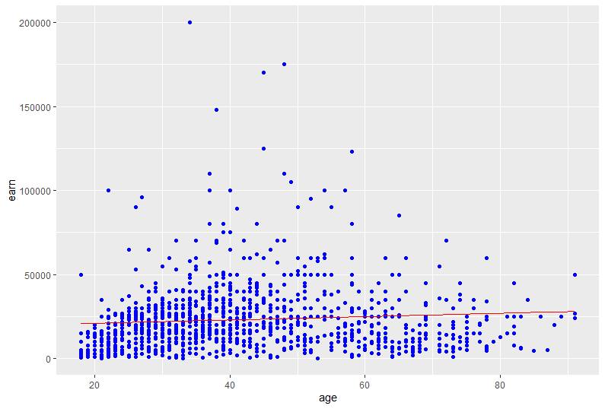

**R Console output from R Studio**

|  |  |  |  |  |
| --- | --- | --- | --- | --- |
| |  | | --- | | # Assignment: ASSIGNMENT 6  > # Name: Gunasekaran, Ragunath  > # Date: 2020-10-06  >  > ## Set the working directory to the root of your DSC 520 directory  > setwd("C:/Users/ragun/Documents/GitHub/dsc520-master/DSC520-new")  >  > ## Load the `data/r4ds/heights.csv` to  > heights_df <- read.csv("data/r4ds/heights.csv")  >  > ## Load the ggplot2 library  > library(ggplot2)  >  > ## Fit a linear model using the `age` variable as the predictor and `earn` as the outcome  > age_lm <- lm(earn ~ age, data=heights_df)  >  > ## View the summary of your model using `summary()`  > summary(age_lm)  Call:  lm(formula = earn ~ age, data = heights_df)  Residuals:  Min 1Q Median 3Q Max  -25098 -12622 -3667 6883 177579  Coefficients:  Estimate Std. Error t value Pr(>|t|)  (Intercept) 19041.53 1571.26 12.119 < 2e-16 ***  age 99.41 35.46 2.804 0.00514 **  ---  Signif. codes: 0 ‘***’ 0.001 ‘**’ 0.01 ‘*’ 0.05 ‘.’ 0.1 ‘ ’ 1  Residual standard error: 19420 on 1190 degrees of freedom  Multiple R-squared: 0.006561, Adjusted R-squared: 0.005727  F-statistic: 7.86 on 1 and 1190 DF, p-value: 0.005137  >  > ## Creating predictions using `predict()`  > age_predict_df <- data.frame(earn = predict(age_lm, heights_df), age=heights_df$age)  > age_predict_df <- data.frame(earn = predict(age_lm, heights_df), age=heights_df$age)  > summary(age_predict_df)  earn age  Min. :20831 Min. :18.00  1st Qu.:21924 1st Qu.:29.00  Median :22819 Median :38.00  Mean :23155 Mean :41.38  3rd Qu.:24111 3rd Qu.:51.00  Max. :28087 Max. :91.00  >  > ## Plot the predictions against the original data  > library("ggplot2")  > ggplot(data = heights_df, aes(y = earn, x = age)) + geom_point(color='blue') +  + geom_line(color='red',data = age_predict_df, aes(y = earn, x = age))  >  >  > mean_earn <- mean(heights_df$earn)  > ## Corrected Sum of Squares Total  > sst <- sum((mean_earn - heights_df$earn)^2)  >  > ## Corrected Sum of Squares for Model  > ssm <- sum((mean_earn - age_predict_df$earn)^2)  >  > ## Residuals  > residuals <- heights_df$earn - age_predict_df$earn  >  > ## Sum of Squares for Error  > sse <- sum(residuals^2)  >  > ## R Squared R^2 = SSM\SST  > r_squared <- ssm/sst  >  > ## Number of observations  > n <- length(coefficients(age_lm))  >  > ## Number of regression parameters  > p <- 2  > ## Corrected Degrees of Freedom for Model (p-1)  > dfm <- p-1  >  > ## Degrees of Freedom for Error (n-p)  > dfe <- n-p  > ## Corrected Degrees of Freedom Total: DFT = n - 1  > dft <- n-1  >  > ## Mean of Squares for Model: MSM = SSM / DFM  > msm <- ssm/dfm  > ## Mean of Squares for Error: MSE = SSE / DFE  > mse <- sse/dfe  > ## Mean of Squares Total: MST = SST / DFT  > mst <- sst/dft  > ## F Statistic F = MSM/MSE  > f_score <- msm/mse  >  > ## Adjusted R Squared R2 = 1 - (1 - R2)(n - 1) / (n - p)  > adjusted_r_squared <- 1 - ((1 - r_squared)*dft / dfe)  >  > ## Calculate the p-value from the F distribution  > p_value <- pf(f_score, dfm, dft, lower.tail=F)  >  >  > # References  > # 1. https://www.r-bloggers.com/2009/11/r-tutorial-series-simple-linear-regression/ | |  | | |  | | --- | | > | | |